ANNEX 2
MATTERS TO BE SPECIFIED IN SECTION 15 PROPOSALS TO DISCONTINUE A SCHOOL
Insert the information asked for in the expandable box below each section.

Contact details
- The name of the local education authority or governing body publishing the proposals, and a contact address, and the name of the school it is proposed that should be discontinued.

Oxfordshire County Council
Michael Mill, Strategic Manager (Property & Assets), 3rd Floor Clarendon House, 52 Cornmarket St, Oxford OX1 3EJ

Implementation
- The date when it is planned that the proposals will be implemented, or where the proposals are to be implemented in stages, information about each stage and the date on which each stage is planned to be implemented.

31st August 2008

Consultation
- A statement to the effect that all applicable statutory requirements to consult in relation to the proposals were complied with.

All applicable statutory requirements to consult in relation to the proposals were complied with. The consultation was carried out in conjunction with the sponsors of the Academy.

- Evidence of the consultation before the proposals were published including—
    - a list of persons and/or parties who were consulted;
    - minutes of all public consultation meetings;
    - the views of the persons consulted; and
    - copies of all consultation documents and a statement of how these were made available.

The informal consultation process took place over six weeks in term time ending on 24 July 2007. As recommended by DCSF guidelines. The aim of the process was to:
- Inform and engage key stakeholders and the public about the proposal to establish an Academy at the current Peers School.
- Raise awareness of and encourage comment on the Academy proposal.
- Develop relationships and links with other organisations that could contribute to the life of the Academy.
- Complete the statutory need for a consultation process in advance of the Executive Cabinet taking a decision on whether or not to issue a school closure notice.

Background

The present Peers School faces a number of major issues. These include a falling student roll, a budget deficit, an Ofsted Notice of Improvement, low GCSE attainment and existing buildings that are unsuitable for a modern school.

Student roll: The school has an admissions number of 210, however, in September 2006 it only admitted 121 students.

Budget Deficit: The school has a significant budget deficit that it needs to reduce and as such it is currently going through a period of voluntary redundancies.

Notice of Improvement: The school has moved out of Special Measures however it still retains a Notice of Improvement with pupil attendance and punctuality remaining marked as unsatisfactory.

GCSE attainment: 25.7% of students attained 5 A* -C grades in 2006 compared to the Local Authority average of 56.4%.

Existing buildings: The buildings are in a poor condition and as such do not inspire students to learn or aid staff to improve teaching an learning.

School Closure Consultation process

The school closure consultation was lead by Oxfordshire County Council working closely with the Academy Sponsors to ensure the principles of partnership were applied throughout the process. The process consisted of the distribution of a consultation brochure, four public consultation meetings, a series of Stakeholder Reference Groups and the establishment of a consultation website. Each of these elements are explained in more detail below.

Consultation Brochure

A twelve page consultation brochure was produced that outlined the Academy proposal and the consultation process. The brochure contained the following headings

- What is an Academy?
- What will the Academy offer?
- The Academy specialisms.
- The Leadership Centre.
- The Academy admissions arrangements.
- The Academy Sponsors.
- Why Peers School?
- The Academy curriculum.
- Community links.
- The Consultation Process and meetings.

It also contained a feedback form that could be returned to the project team via;

- The Academy Post Box in the Peers School reception area;
- By post to a designated address;
- By hand at the consultation meetings.

Four thousand copies of the brochure were distributed to;

- Peers School students, parents/carers, staff and governors;
- Feeder Primary school students / parents, Heads and Chairs of Governors;
- Neighbouring secondary school heads;
- Local higher and further education organisations;
- Local Councillors and MP’s;
- Local Sports and Business Organisations;
- Local information points, including doctors’ surgeries, libraries and places of worship.

A copy of this is attached at Appendix A.

Public Meetings

Following consultation with the school governors the meetings were organised to take place at different times in four different locations that took account of the catchment areas for the school to provide the maximum opportunity for opinions to be heard.

The Public meetings were held at:-

Meeting | Date | Venue | Time
1 | 12 June 2007 | Blackbird Leys Community Centre | 17.00 to 19.00
2 | 14 June 2007 | Rose Hill Community Centre | 19.00 to 21.00
3 | 18 June 2007 | Peers School | 16.30 to 18.30
4 | 19 June 2007 | Pegasus School | 15.30 to 17.30

The meeting schedule was publicised through distribution of a flyer, the information brochure and in local newspapers, a copy of the flyer is attached in Appendix B.

The meeting were attended by approximately 150 people in total of whom approximately 20 were parents of Peers School students. The meeting were also attended by other parents, local Councillors, members of the Oxfordshire Anti - Academies Alliance, staff and governors from Peers and other schools as well as local press agencies.

At the beginning of each meeting short presentations were given by Leslie Stephen, Director of Education Oxford Diocesan Board of Education, Hilary Lowe, Assistant Dean, Oxford Brookes University and Shannon Moore, Assistant Head of the Educational Effectiveness Service, Oxfordshire County Council. The meetings were focussed on questions from the audience and followed an agreed format to ensure sufficient time was given to each topic.

The main topics addressed were:

- Education
- The Academy Organisation
- Christian Faith and Principles
- Staffing
- Sponsors and Partners
- Wider Oxfordshire Issues
- Building programme
- Governance
- Community Issues
- Consultation Process

During the meetings attendees made a number of positive and negative comments about the proposal to establish an Academy on the site of the existing Peers Schools. The majority of attendees agreed that the school needed a radical change to ensure that students were provided with a higher standard of education as soon as possible. Some however, questioned if an Academy was the best solution for delivering this change. The Headteacher of Peers School commented that the proposal had already helped to attract staff to vacant posts and that new buildings were needed.

A question and answer document was distributed in August / September to give more information to those who could not attend the meeting. A copy of this paper can be found in Appendix C.

Stakeholder Reference Groups (SRGs)

Four Stakeholder Reference Groups have been established:

- Staff
- Governors
- Students and Parents
- Community

The SRGs have a key gate keeping role during the consultation process. They provide stakeholders with the opportunity to let Sponsors know what changes they would like to see while enabling the Sponsors to learn about the key issues facing the school. They also ensure that both stakeholders and the Sponsors are kept up to date with developments at the school and with the Academy proposal. Their views are fed through to the Project Steering Group (PSG) for discussion and decision-making.

A number of meetings have already taken place and the groups will continue to meet until June/ July 2008. Details of the meetings that have already taken place are provided below.

Staff Consultation

A letter was sent to all Peers staff from the Local Authority in May 2007 that provided details of the proposals, the process of establishing an Academy and contract details for the LA’s HR team as well as the project manager for the proposed Acadey. A Copy of this letter is attached in Appendix D.

All staff were also given a copy of the DfES publication ‘Working in an Academy’ guide in March 2007.

A staff presentation was made by the Sponsors on 18th July 2007, approximately 50 staff attended. Subjects discussed included the consultation progress, future communications strategy, Principal Appointment, TUPE and progress on the proposed new buildings.

The Local Authority has organised a series of Trade Union meetings the first of which took place on 19 July 2007. Further monthly meetings with the Trade Unions have been agreed from September 2007- June 2008 inclusive under the chairmanship of the Local Authority.

Two Stakeholder Reference Group meetings have taken place with 8 staff members on 28 June 2007 and 19 July 2007 and these will continue on a monthly basis from September 2007. Key issues raised by staff were:

- Stay focussed on Children.
- Include Cooking, Music and Performing Arts facilities in the new buildings.
- “Quick wins” in September 2008 are essential, including a thorough clean internally.
- Improve catering facilities.
- Improve staff room facilities including IT and photocopying area.
- Mabel Pritchard Special School should be incorporated into new Academy if additional funds can be found.
- Remove corridors.
- Improve toilet and shower facilities for both students and staff.
- Provide a “Coffee Shop” environment for students – split by age-groups.
- Split breaks during day by age-groups.
- Incorporate exclusion areas.
- Re-brand the school/Academy.

Governors Consultation

Although the original suggestion was for staff and governors to be involved in a single SRG, staff wished to be consulted separately.

The Project Manager from Mouchel Parkman together with representatives from the Sponsors and Local Authority has attended two Governor Academy Task Group meetings on 29 March and 3 May. The main points raised were:

- Staff Recruitment/retention is essential.
- TUPE/Staff matters must be handled tactfully
- Communication with staff must be informative and regular.
- Involvement with the local community must be well planned and effective
- “Quick wins” in September 2008 must be effective and noticeable
- Facilities for cooking, music and Performing Arts must be incorporated in the design of the new buildings.
- Listen to the staff needs in the new building design.
- Involve Parents in any proposed changes to the Memorial Garden.
- Involvement with feeder Primary School Headteachers is imperative
- Sports Specialism is not just football

The Chair of Governors both past (Nicola Sheldon) and present (Andrew Parsons) are members of the Project Steering Group (PSG) and maintain an essential link between the current Governing Body and the proposals for the new Academy

Parent/Carer Consultation

A letter was sent from the Local Authority to all parents/carers of current students on 5 May, a copy is attached in Appendix E. The letter provided details of the proposal and consultation process. It also reassured parents that all students currently at the school are entitled to automatically transfer to the Academy and will continue to receive a free education should the Academy proposal be accepted.

All letters contained a contact email address for any queries or requests for further information together with a sheet containing general information about Academies.

Two Parent and Community Stakeholder Reference Group meetings have taken place on 4 July and 25 July, with 1 and 2 attendees respectively, the main points raised were:

- Effective communication between the Academy and local community is essential.
- Involve the local community with Leadership Development with a view to becoming a Governor.
- Can any tasks be “handed over” to the community to manage on their own?
- Reduce the number of exclusions.
- Tidy up the appearance of the School.
- How can community become involved with branding of the Academy?
- What can be done to stop local children going to schools elsewhere in Oxford?
- Previous consultations have been failures e.g. Sports Centre – don’t make the same mistakes again.

The Sponsors are very keen to increase the representation on these groups and are currently working with John Ord of OCC and community representatives to increase participation and develop a community strategy. In order to help raise the level of involvement the school also sent a letter to all parents inviting them to attend the meetings.

Student Consultation

A SRG meeting was held with 8 members of the Student Council at Peers school on 27 June. Students highlighted the following areas as being of concern to them:

- Toilet cleanliness.
- Inadequate shower provision , with unsatisfactory privacy.
- Excessive use of supply teachers, some who cannot speak good English.
- Poor behaviour throughout the school.
- The general unsatisfactory condition of school buildings.
- Too many ‘no go’ areas.

The meeting took place at the school and was observed by a non teaching member of staff in order to encourage students to speak freely about their feelings about the school.

A further SRG with students was arranged for July 2007 however, it was cancelled at the request of the school. Monthly meetings have been scheduled from September 2007.

Feeder Primary Schools

A consultation meeting took place on 1 May with the Headteachers of six feeder primary schools to ascertain their views on Peers School and what changes they would like to see before they would encourage their parents to apply for a place at the proposed Academy. This meeting was attended by the Sponsor’s Educational Adviser, Roy Blatchford, and the Project Manager, Chris Dennis.

General perceptions include:

- That bullying at the current school is rife and not adequately dealt with.
- The transition process for new Year 7 pupils needs to be handled more sensitively by staff.
- Behaviour, attitude and attendance are all in need of radical change.
- That there are an unacceptably high number of exclusions.
- That the current campus is difficult to navigate around and the standard of the buildings is extremely bad.
- There needs to be greater engagement with the local community.

A further meeting with the primary school Headteachers is being arranged for September 2007.

Details of the primary feeder schools and the headteachers involved are attached in Appendix F.

Written Feedback

At the end of the Informal Consultation period on 24 July 2007 [no further responses were received after this date] 22 responses had been received through the feedback form (15), letters (4) and via the Academy website (3). The responses contain messages expressing support or concerns, agreement or disagreement, towards the Academy proposal. The feedback has been summarised in the table below (the individual responses will made available)

Consultation Feedback - Breakdown of Responses

 |  | Responses |  | Summary of Points Raised |  | Category Breakdown
 | FOR | 10 |  | - Money needed, Values needed, increase numbers.  - Needs a restart and more focused approach  - Facilities and resources needed in the Community  - Will improve the links with Primary feeder schools  - Better teachers, opportunities and image.  - More pride created for the school. Better image in the community and learning environment  - Better buildings and equipment. |  | - Parents Peers  = 2  - Parent of Primary student = 4  - Governor of Feeder School  = 2  - Resident  = 2
AGAINST |  |  | 12 |  | - Christian values and private funding.  - Multicultural area, too much focus on Christianity.  - Privatisation via back door, no guarantee of academic improvements.  - Too many exclusions  - School was left to deteriorate in the hands of the Local Authority.  - Ownership and running of Academy given to sponsors.  - Students don’t need change  - Building on sports fields?  - Principal appointed before Academy approval.  - Profit related |  | - Local Resident  = 9  - Governor at Feeder School =1  - Transport and General Workers Union  = 1  - Oxford Teachers Union Association  = 1

Oxford Academy Website

An information website has been set up as part if the consultation process and was launched on 8 June 2007 to give greater access to information about the proposed Academy and the consultation process. The website address www.theoxfordacademy.co.uk was prominently advertised at all of the public consultation meetings and is displayed on the information board at the school.

The website currently provides information on a number of key issues such as:

- What is an Academy?
- The Academy’s Specialism.
- The Academy’s Sponsors.
- What Happens Next?

The website also contains a feedback form that can be completed and submitted through the website to the Project Management company. Three of the feedback responses received were sent via the website. The website is an ongoing resource that will be updated on a regular basis as the project progresses and will eventually be replaced with a permanent website for the Academy if the proposal is accepted

Notice Boards

Two Notice Boards are being utilised within the school to ensure that the proposal is visible. The notice board in the reception area provides details of the Academy web-site, the Project Manager’s contact details and a copy of the consultation brochure. The notice board in the staff room provides more detailed information related to staff.

Next Steps

The informal consultation period has now been completed and as such the project will now move to the next stages of consultation. The first will be the consultation on the issue of school closure notices if an agreement is reached to issue the notices. This will be lead by the Local Authority.

The second is known as the good practice consultation and includes giving more information about the Academy proposal and seeking further comments to ensure that the Academy will meet the expectations of the people it serves. This will be led by the Sponsors.

Consultation of the school closure notice
Oxfordshire County Council (OCC) will post the notice (if agreed for issue) outside of the Peers School entrance and write directly to parents, staff and Governors to inform them of the decision to issue the notice. The notice will also appear in local press and be communicated to other stakeholders.

OCC will lead a 4-6 week consultation process during which stakeholders will have a second opportunity to comment on the proposal to close the school and open the Academy. Details of the consultation process will also be publicised via a newsletter, the website and the school notice board. In addition the SRG’s will have the opportunity to discuss the notices and raise any further questions that they may have.

Good Practice Consultation
The good practice consultation will work hand in hand with the consultation on the school closure notice and will consist of a number of on going activities. With the aim to gaining real buy in and ownership of the proposed Academy with those who will use it on a day to day basis. Elements of this consultation are described below.

Student consultations
A Student Stakeholder Group meeting is planned in September and monthly thereafter. Consultations with students in each school year are also planned during September.

From September onwards consultation sessions will take place with larger numbers of students divided by year group to give a wider number of students the opportunity to share their views of various issues with the Sponsors. Students will also have the opportunity to provide their comments on various issues through questionnaires and competitions.

This will give more students the opportunity to let the Sponsors know what they like about the school and what changes they would like to see. This will include discussions on the every day organisation of the school, the existing and new buildings as well as food and uniform.

These meetings aim to give students a strong sense of ownership as early as possible so that they are directly involved in creating the proposed Academy and have a sense of pride about it from the beginning.

Staff consultations
The staff stakeholder reference group will take place on a monthly basis from September 2007 to September 2008

OCC and the Sponsors will be working together to organise a series of meetings and presentations to staff that will keep them up to date on progress being made and provide a forum for questions to be raised. Staff have been provided with a contact email for the Project Manager who will work with OCC and the Sponsors to ensure individual questions are responded to quickly.

Staff will be provided with a series of staff information booklets that give them more in depth details of developments and the Academy proposal. The booklets will focus on issues that are particularly relevant to staff. The first of these booklets was provided before the end of term.

At the request of the Local Authority the DCSF have provided a TUPE consultant to the project to provide expert TUPE support and add capacity to OCC’s HR team. The consultant will be able to answer technical TUPE questions and attend monthly meetings with Trade Unions.

Parent and community consultations
The Sponsors, school and OCC are keen to get more parents involved in the Academy proposal and especially to increase attendance at the SRG’s.

The Project Manager met with John Ord of Oxfordshire County Council on 18 July to discuss the collaborative development of a Community Development Strategy involving the Sponsors and Local Authority.

Open Days
The Sponsors will organise 3 open days for students and parents to take place in September/October 2007 that will be used to talk to potential students/parents about the opportunities that will be available at the Academy if the proposal is accepted.

A mini prospectus will be produced in advance of these open days to be distributed to existing students and students in Years 5 and 6 of feeder primary schools.

The Local Authority, Sponsors and Project Manager are discussing with Oxford United Football Club the possibility of joint Open Day at the Oxford United Stadium involving the players and parents of local children’s football clubs.

Newsletter
During early September 2007 a newsletter will be produced giving an update on the Academy progress so far and further newsletters will be issued during each term leading up to the proposed Academy opening in September 2008. The newsletters will also be posted on the Academy website and distributed throughout the community.

School notice board and website
Both of these information sharing tools will be kept up - to - date as work progresses and include details of meetings and other developments.

Buildings
If the proposal is accepted users will be asked to participate in a series of design user groups that will aim to gain an understanding of what students, staff, parents, Governors and the community want the new buildings to achieve. Staff and students will also be consulted on the immediate improvements that will be made to the existing buildings.

Question and Answers
During the next stage of the project development regular question and answer sheets will be released to provide detailed responses to questions that are raised by different groups. These will be widely distributed, added to the website and school notice board.

Admissions Policy
Should the proposal be accepted all students attending or those who have been offered a place at Peers School prior to the opening of the proposed Academy will be entitled to be transferred to the new Academy on 1st September 2008. Students who do not wish to transfer to the Academy will be offered alternative places by OCC.

The Sponsors wish to retain the full Local Authority admission policy in order to encourage local students to take up places at the proposed Academy and reduce the number of students travelling away for their secondary education.

As part of the feasibility phase the Sponsors will consult on the policy in September 2007 with stakeholders including the OCC Admissions Forum that they will not be making changes. This process will invite comments on the policy.

Consultation Strategy

An overall consultation strategy was agreed by the Project Steering Group in March 2007 and is attached in Appendix G for reference. The strategy is an ever evolving document and will continue to move as the project moves forward.

Appendix A: Academy Brochure


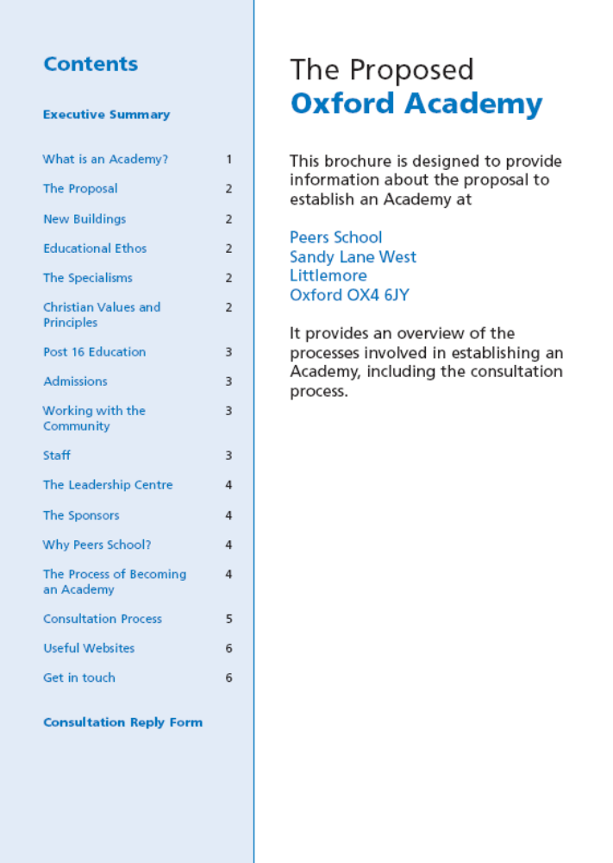
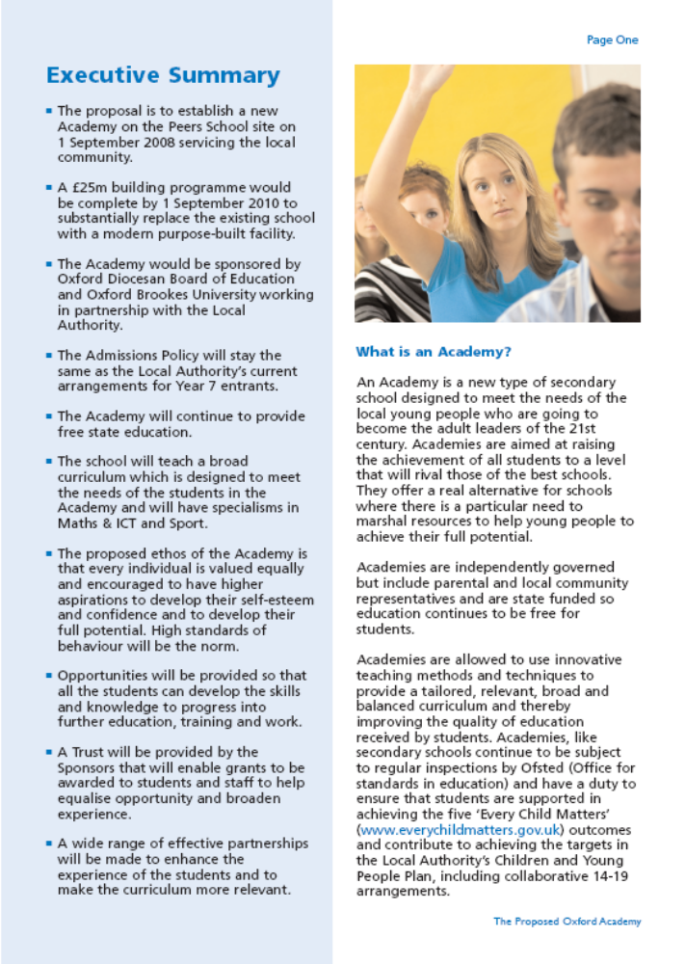

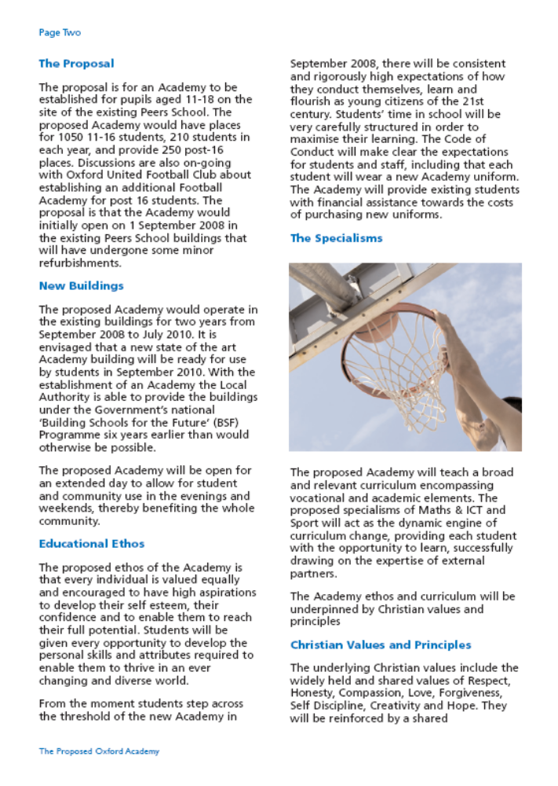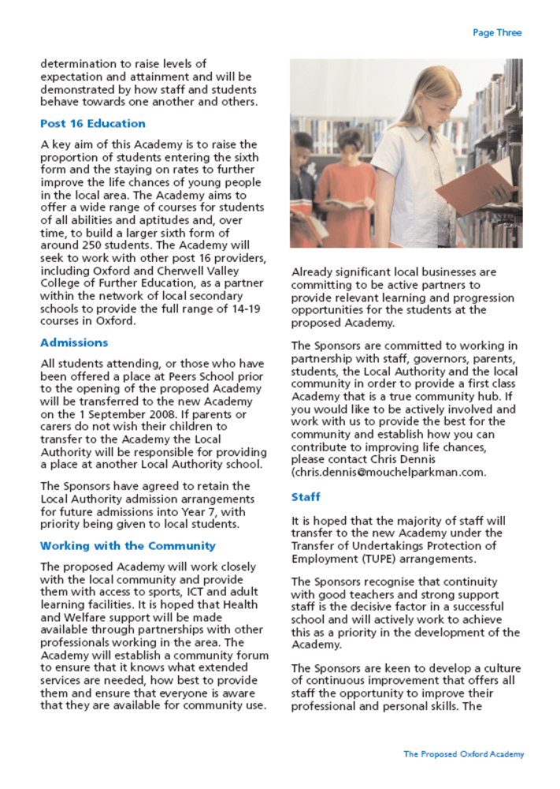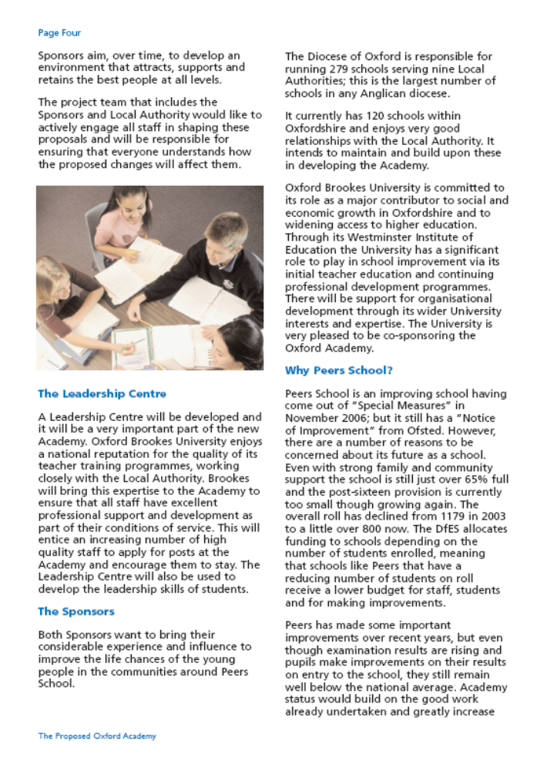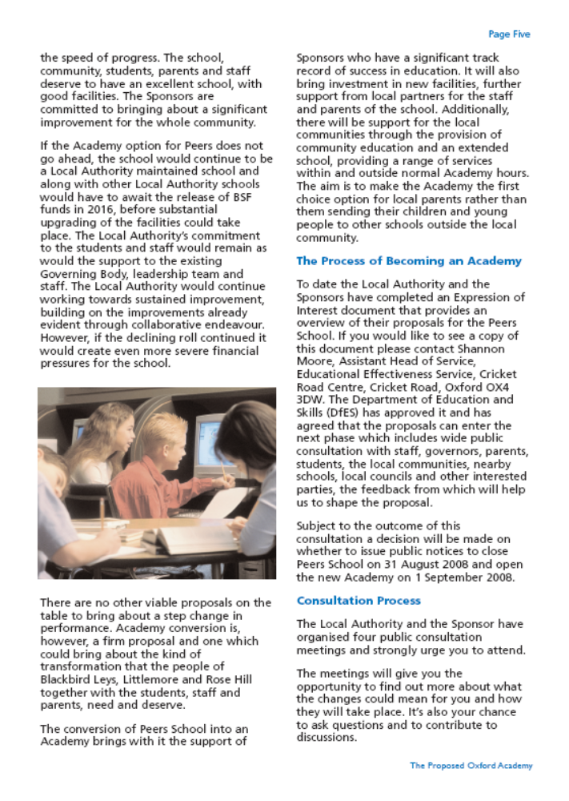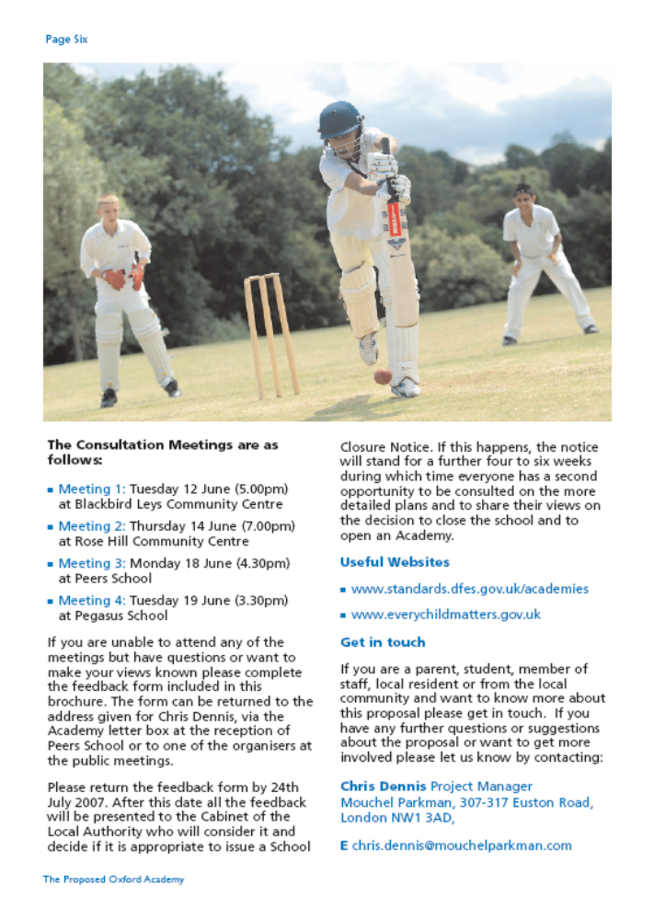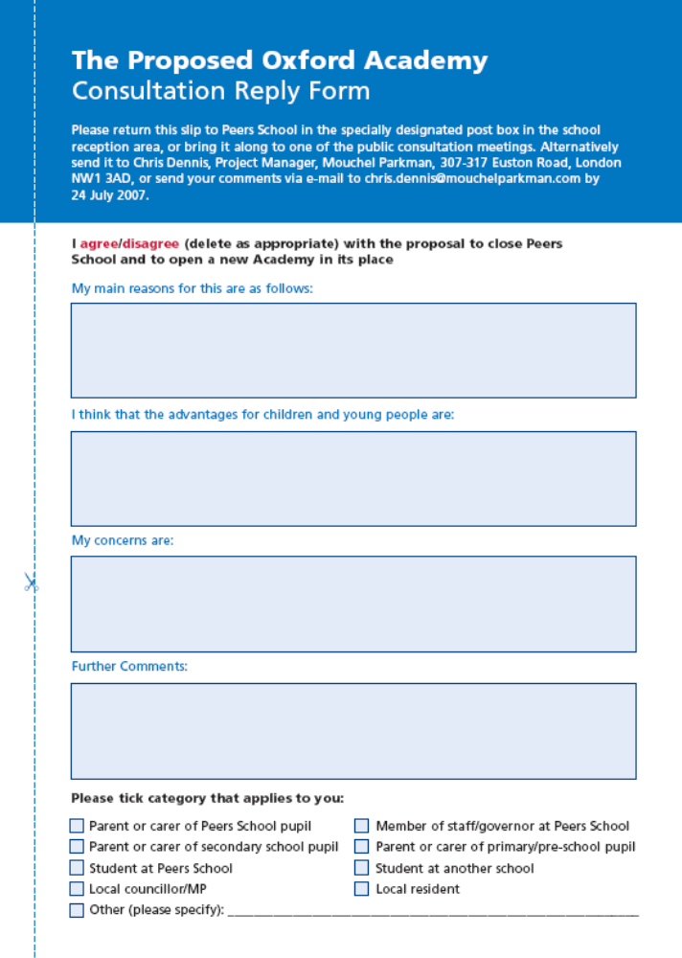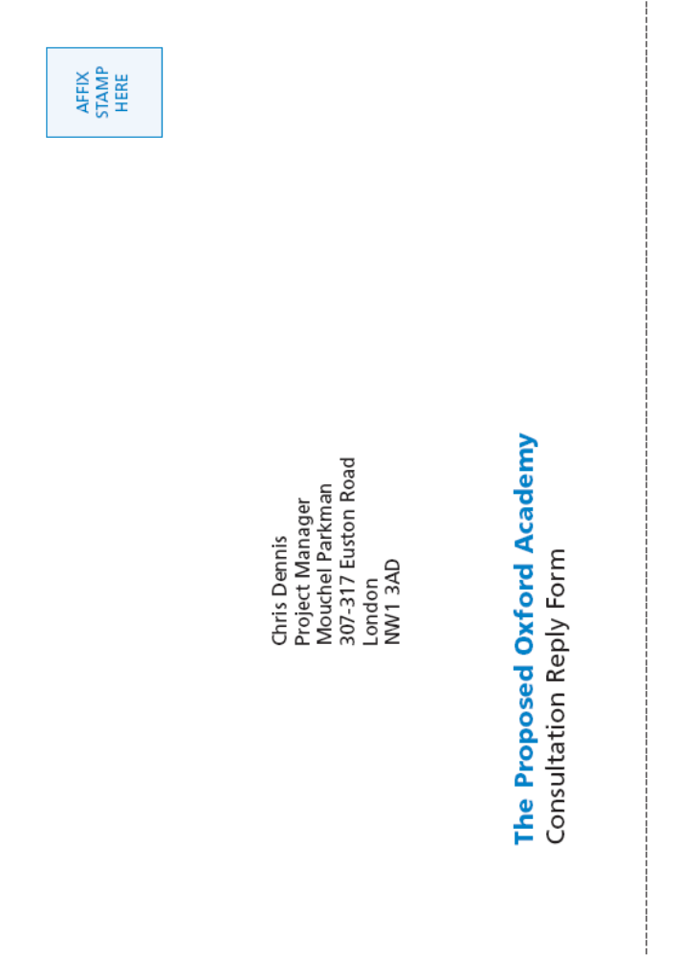
Appendix B: Flyer

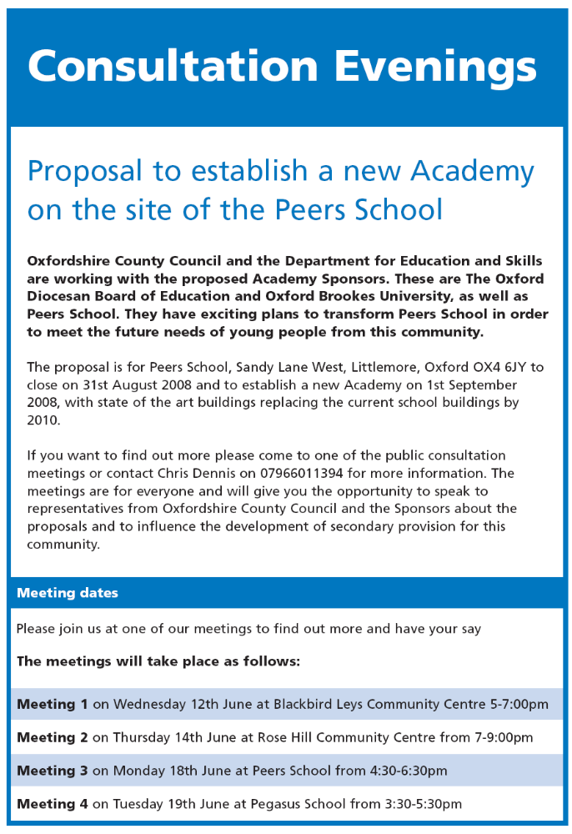

See separate document for other appendices

Objectives
- The objectives of the proposal.

It is intended to close Peers School on 31 August 2008 to enable an Academy to open on 01 September 2008, initially in the same buildings and on the same site continuing to serve the local community. By September 2010 it is expected that the substantially new-built Academy will be open.

The sponsors have the following vision for the Academy:

Education matters in society: the provision of a well ordered, stimulating learning environment is a common right for all our children.

• The Academy should articulate social and moral values and respect for others, irrespective of their class, sex, race or religion.
• The Academy will promote the highest achievement in youngsters, irrespective of their abilities or self-expectations. Competition and collaboration are both equally important to learning. The aspirations of all our students will be nurtured.
• The Academy will celebrate students’ achievements and challenge fixed notions of ability. We will value and reward young people’s verbal, practical, academic, sporting, artistic and leadership skills.
• An effective and flourishing Academy should be ‘public’ rather than ‘private’, explaining to parents what is being taught and how the curriculum is being interpreted. It should be open to praise and constructive feedback in a genuine spirit of partnership.
• An effective Academy should work closely with neighbouring schools to improve opportunities for children and young people.

Standards and Diversity
- A statement and supporting evidence indicating how the proposals will impact on the standards, diversity and quality of education in the area.

The Academy will be an exciting and inspiring place to learn where the talent and imagination of every student will be captured and nurtured. The curriculum will be broad, relevant and balanced providing a challenging learning environment for students of all abilities. A key aim of the Academy
will be smooth transition from the local primary schools and a Year 7 curriculum that will link carefully with the primary curriculum, developing literacy, numeracy, ICT skills and emotional skills. The Key Stage 3 curriculum will be followed by students in Years 7, 8 and 9, with as many students as is appropriate completing the key stage in two years, allowing them to fast-track to GCSE and high quality vocational opportunities. There will be opportunities for all students to develop sound literacy, numeracy and ICT skills at this important stage of their education. The Key Stage 4 and 5 curriculum will be covered through Years 9 to 13, supported by extensive collaboration with a range of external partners. This will enable an exciting range of GCSEs, diplomas, vocational subjects, A Levels and foundation degrees, as well as a Sports Academy, including a football course open to young people aged 16-18.

The Academy therefore will continue to work closely with the neighbouring maintained schools to ensure continuity and progression, following the agreed admissions procedures, engaging in the Children and Young People’s Plan and the local 14-19 developments. Specialisms have been chosen to complement those of neighbouring city schools and it is envisaged that the Leadership Centre will be developed with the support of the LA, to service maintained schools as well as the Academy.

In this way the Academy will add to the choice and diversity of provision, serving the local communities and with the sponsors working in collaboration with a range of partners including OCVC, local companies, OCC and the local community.

The Academy will be bringing a fresh approach to meeting the needs of this community through partnership and this will inform the provision in other schools and the way that OBU and other agencies work with them also.

Provision for 16 -19 year olds
- Where the school proposed to be discontinued provides sixth form education, how the proposals will impact on—
    - the educational or training achievements;
    - participation in education or training; and
    - the range of educational or training opportunities,
for 16-19 year olds in the area.

The school will be succeeded by an Academy on the same site offering provision for pupils 16-19. The further development of the Football Academy in partnership with Oxford United Football Club will enable the number of post-sixteen students to expand.

Need for places
- A statement and supporting evidence about the need for places in the area including whether there is sufficient capacity to accommodate displaced pupils.

There are currently 838 pupils on roll at the school. The new Academy opening on 1st September 2008 in the same buildings and on the same site will continue to accommodate all the current pupils who are attending the school at its closure. The capacity of the school is 1220 and the new Academy will initially have a capacity of 1400 due to a proposed expansion of the Sixth Form to allow the Football Academy to develop in partnership with Oxford United Football Club. Parents will be able to apply for places at other schools through the normal admission arrangements.
- Where the school has a religious character, a statement about the impact of the proposed closure on the balance of denominational provision in the area and the impact on parental choice.

The school does not have a religious character although the principal Sponsor of the Academy is the Oxford Diocese (Church of England) so Christian values will underpin the development of the Academy. The opening of an Academy will extend parental choice by increasing choice and diversity. It will be open to children of all faiths and with no faith.

Current School Information
- Information as to the numbers, age range, sex and special educational needs of pupils (distinguishing between boarding and day pupils) for whom provision is made at the school.

The school is an 11-18 co-educational comprehensive day school. There are children with special needs that can be met at the school and those with Statements of Special Educational Need receive provision appropriate to this setting. There is no specific provision reserved for children with special educational needs although there will be a special partnership with Mabel Pritchard School which will share the site and some of the Academy facilities.

Displaced Pupils
- Details of the schools or further education colleges which pupils at the school for whom provision is to be discontinued will be offered places, including—
    - any interim arrangements;
    - where the school included provision that is recognised by the local education authority as reserved for children with special educational needs, the alternative provision to be made for pupils in the school’s reserved provision; and
    - in the case of special schools, alternative provision made by local education authorities other than the authority which maintains the school.

No interim arrangements are required as an Academy will open on the school site on 1st September 2008 and all existing pupils in attendance at the school including those with special educational needs will be offered a place.

- Details of any other measures proposed to be taken to increase the number of school or further education college places available in consequence of the proposed discontinuance.

No other measures to increase places elsewhere are required.

Impact on the Community
- A statement and supporting evidence about the impact on the community and any measures proposed to mitigate any adverse impact.

Information about impact on the community is contained in the consultation documents. As the school will become an academy there is not expected to be an adverse impact on the community. It is intended that the school will be at the heart of the local community and that most existing community facilities will continue to be available but in better buildings

- Details of extended services the school offered and what it is proposed for these services once the school has discontinued.

The Academy will be open as an ‘extended school’ to the whole community,
and will include youth, adult and continuing education. This means that the
Academy will provide a range of services that support the students, families
and community throughout the week and at weekends. This will include
masterclasses and advanced learning days/weeks in the arts, sciences and
other disciplines, linked to the two universities and the wider cultural life of
the city. Sponsors will of course be continually consulting with the community to find out what needs and interests are to ensure that the services we provide are relevant. Currently Adult Education, Leisure Services, Parent Education, Library Services are offered. Negotiations are taking place with providers of these services about what can be offered when the school closes.

Travel
- Details of length and journeys to alternative provision.

Not applicable.
- The proposed arrangements for travel of displaced pupils to other schools including how they will help to work against increased car use.

Not applicable.

Related Proposals.
- A statement as to whether in the opinion of the local education authority or governing body, the proposals are related to any other proposals which may have been, are, or are about to be published.

The proposal is not linked to another statutory proposal but approval can only be given conditional on Secretary of State approval for the Academy.

Rural Primary Schools
- Where proposals relate to a rural primary school designated as such by an order made for the purposes of section 15 of the EIA 2006, a statement that the local education authority or the governing body (as the case may be) considered—
    - the likely effect of discontinuance of the school on the local community;
    - the availability, and likely cost to the local education authority, of transport to other schools;
    - any increase in the use of motor vehicles which is likely to result from the discontinuance of the school, and the likely effects of any such increase; and
    - any alternatives to the discontinuance of the school,
as required by section 15(4) of the EIA 2006.

Not applicable

Maintained nursery schools
- Where proposals relate to the discontinuance of a maintained nursery school, a statement setting out—
    - the consideration that has been given to developing the school into a children’s centre and the grounds for not doing so;
    - the body’s assessment of the quality and quantity of the alternative provision compared to the school proposed to be discontinued and the proposed arrangements to ensure the expertise and specialism continues to be available; and
    - the accessibility and convenience of replacement provision for local parents.

Not applicable

Special educational provision
- Where existing provision for pupils with special educational needs is being discontinued, a statement as to how the local education authority or the governing body believes the proposal is likely to lead to improvements in the standard, quality and/or range of the educational provision for these children.

Not applicable

